# Core Values Exercise

Core values are set of personal attributes unique to you. In this activity, please take the time to think about and categorize your core values. As we discuss artificial intelligence and applications of AI technologies, you might like to keep your values in mind and work on relating them to both technical and societal factors that go into making AI ethical.

**1)** **Determining your core values:** Look at the list of values below. Without overthinking, circle or underline the attributes that resonate with you. Please add your own core values because this list is incomplete.

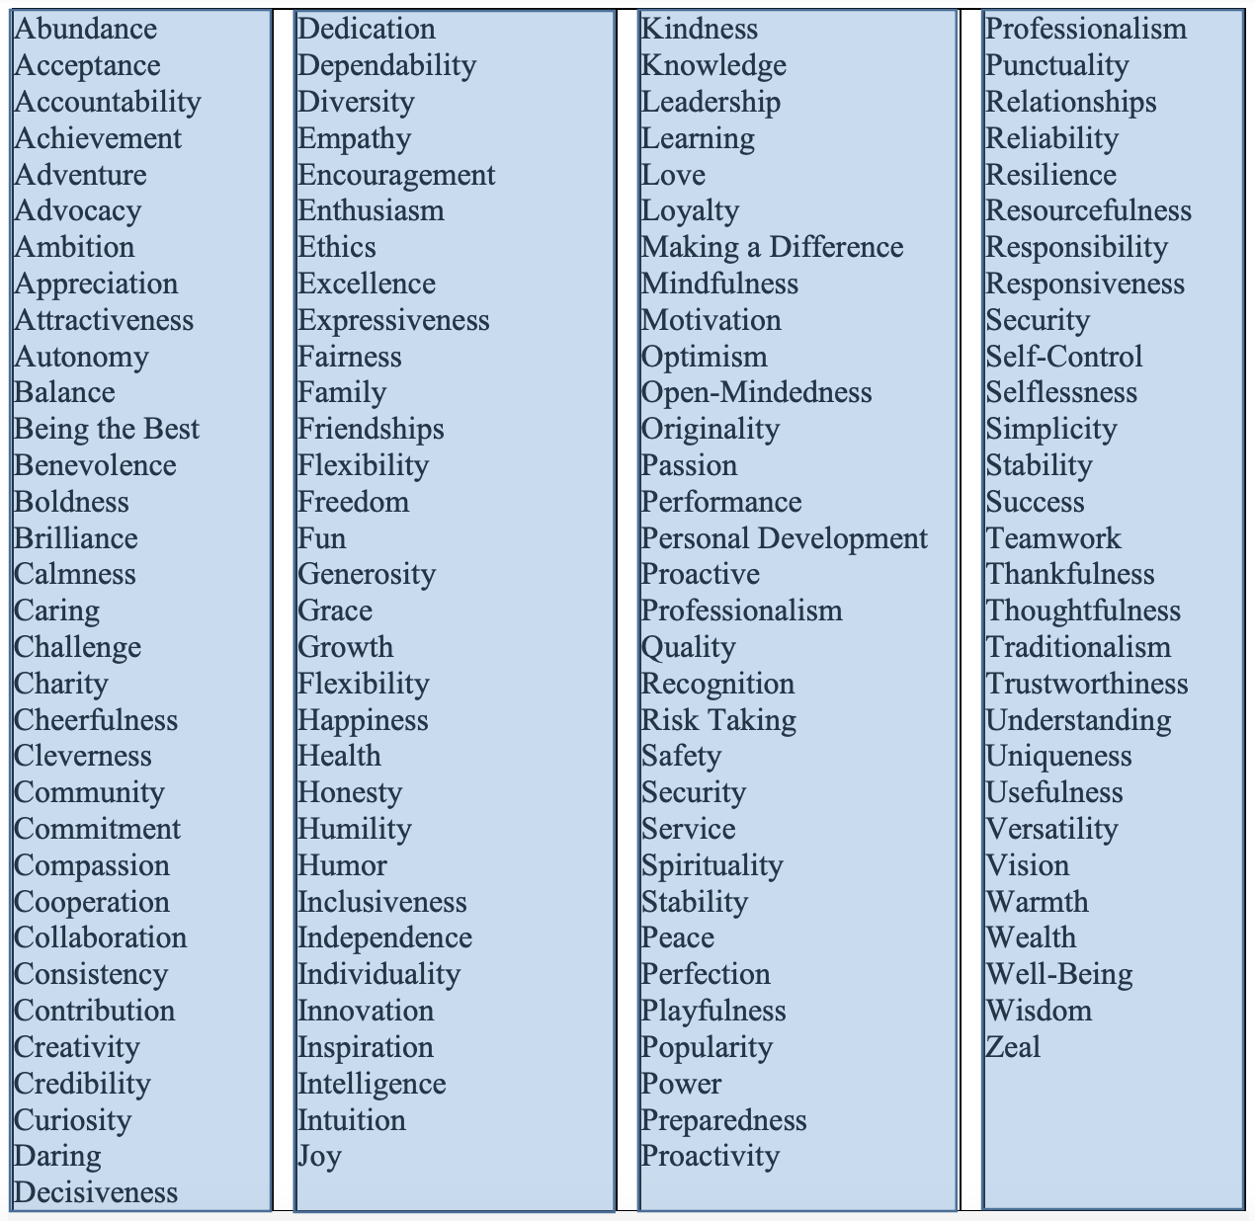

**2a)** **Group your list of core values into attributes with similar themes in the table below.**

E.g., you may group “Acceptance, Inclusion, Compassion, Kindness, Trustworthiness” or “Advocacy, Making a Difference, Proactivity, Boldness”

|  |  |  |  |  |
| --- | --- | --- | --- | --- |
| Group 1 | Group 2 | Group 3 | Group 4 | Group 5 |
|  |  |  |  |  |
|  |  |  |  |  |
|  |  |  |  |  |
|  |  |  |  |  |
|  |  |  |  |  |
|  |  |  |  |  |
|  |  |  |  |  |
|  |  |  |  |  |
|  |  |  |  |  |

**2b) Highlight one word from each column that represents that quality.**  Each column of the above table should have a single word representing the group of values.